**Føroyskur stílur Latast inn 5. nov. 2020**

**Frítíðarítriv**

   

**Ein góður vinur**

 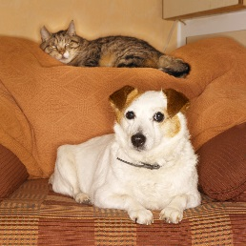 

**Heimbygdin**

[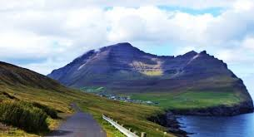](http://www.google.com/imgres?imgurl=http://aktuelt.fo/myndir/myndin-13057_ccc_660_358.jpg&imgrefurl=http://aktuelt.fo/storur%2Bdagur%2Ba%2Bvidareidi%2Bnu%2Bkemur%2Btunnilin.html&h=358&w=660&tbnid=rJ9k395nBuERxM:&zoom=1&docid=onfTxPV0nbgYfM&hl=da&ei=_5hPVOKSC66M7Aa7hYGgDg&tbm=isch&ved=0CCoQMygJMAk&iact=rc&uact=3&dur=757&page=1&start=0&ndsp=34) [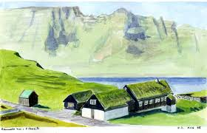](http://www.google.com/url?sa=i&rct=j&q=&esrc=s&source=images&cd=&cad=rja&uact=8&ved=0CAcQjRw&url=http://www.olejacobi.dk/Faeroe/Vidareidi-eng.html&ei=G5lPVKqmGYXmaOmmgagP&bvm=bv.77880786,d.ZGU&psig=AFQjCNH-Dt3WXx7N4rkqpBmmex7Hd9neRQ&ust=1414589055529909) [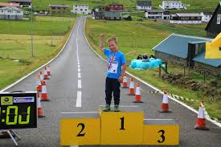](http://www.google.com/url?sa=i&rct=j&q=&esrc=s&source=images&cd=&cad=rja&uact=8&ved=0CAcQjRw&url=http://treysti.fo/news-urslit%2Bvidareidis%2Brenningin%2B2014.htm&ei=UZlPVPa5H8Lwap6VgcgL&bvm=bv.77880786,d.ZGU&psig=AFQjCNH-Dt3WXx7N4rkqpBmmex7Hd9neRQ&ust=1414589055529909)

**Kendir persónar**

  

***Myndirnar omanfyri eru bert til íblástur.***

**Soleiðis skrivar tú: *Inngang/byrjan – Greið frá/viðgerð - Endi/niðurstøðu.***